Instructions:
- Just so you know I've tried dozens of browser tools (such as OpenManus Playwright and more -- huge AI fees!) and hundreds of hours to find the right way to do this. I found a Chrome browser extension that can follow a Python script to OPEN a trade. MODIFY a trade. and CLOSE a trade. This way, no AI fees, nothing like that. All browser automated. This doesn't cost you anything !

This turns Mimic Trades into AUTOMATED Mimic Trades.

1- I run this on 2 x Chrome browsers. I tried edge and others, they don't seem to work good. Chrome works the best.

2- Install a Chrome extension called tampermonkey. This takes over the automation and keyboard controls for you.
https://chromewebstore.google.com/detail/tampermonkey/dhdgffkkebhmkfjojejmpbldmpobfkfo
https://www.tampermonkey.net/
Follow the instructions to activate and make tampermonkey active so it can control and click on browser links.

3- Upload the Javascript to Tampermonkey. I've gone through about 50 revisions of this. All updated and coded with Claude Code in Python script.
(see screenshot)

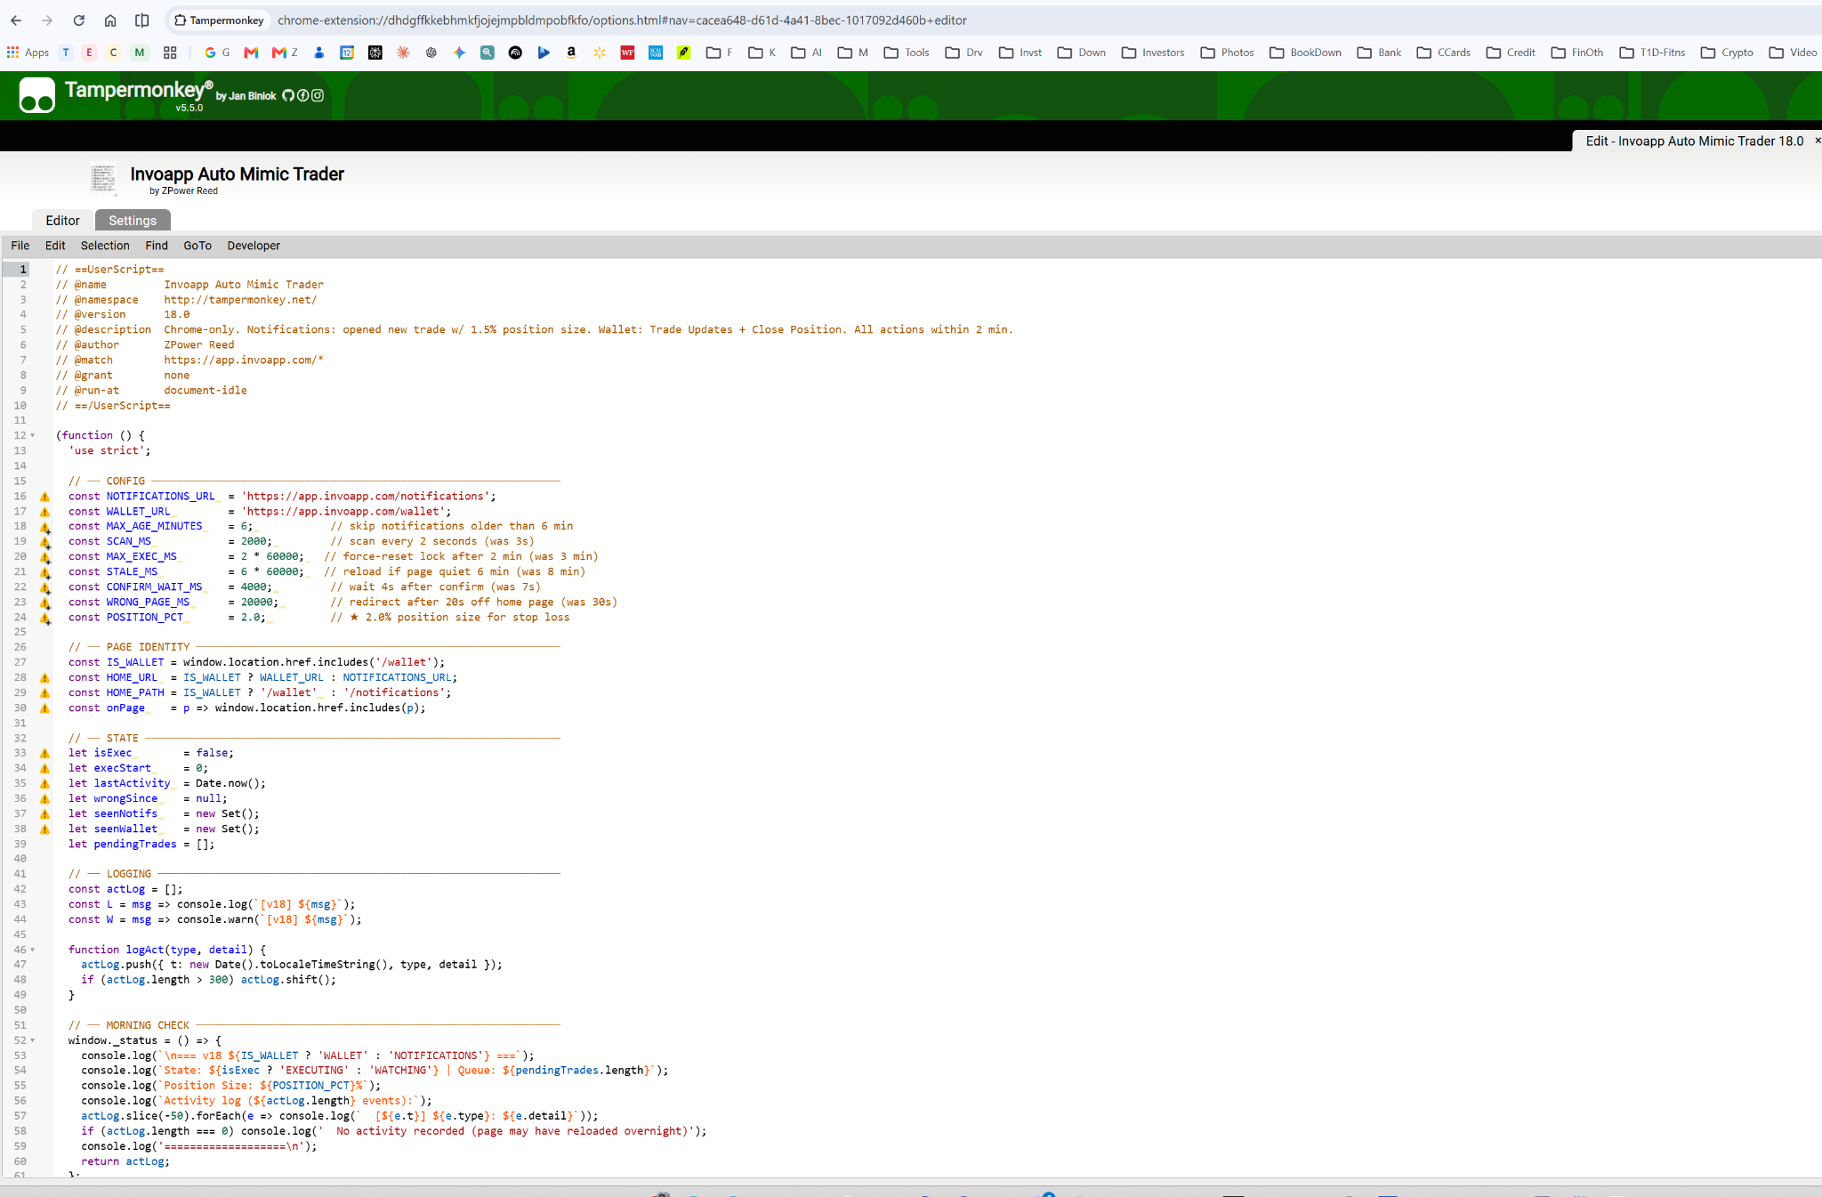

The Javascript is in the TXT file attached.

4- You need 2 chrome browsers open for this to work. One for NEW ORDERS. The other for MODIFICATION and CLOSE orders.
Tab 1 | app.invoapp.com/notifications | Open new trades (mimic trade)
Tab 2 | app.invoapp.com/wallet | Trade Updates + Trader Closed

Pages are refreshed randomly, so the Invo system doesn't block you. Between 20 to 90 seconds if I remember right.

Expert Tip! Hit F5 to refresh the chrome browser after you upload the python script. That causes the Chrome browser to refresh the updated Tampermonkey code you uploaded.

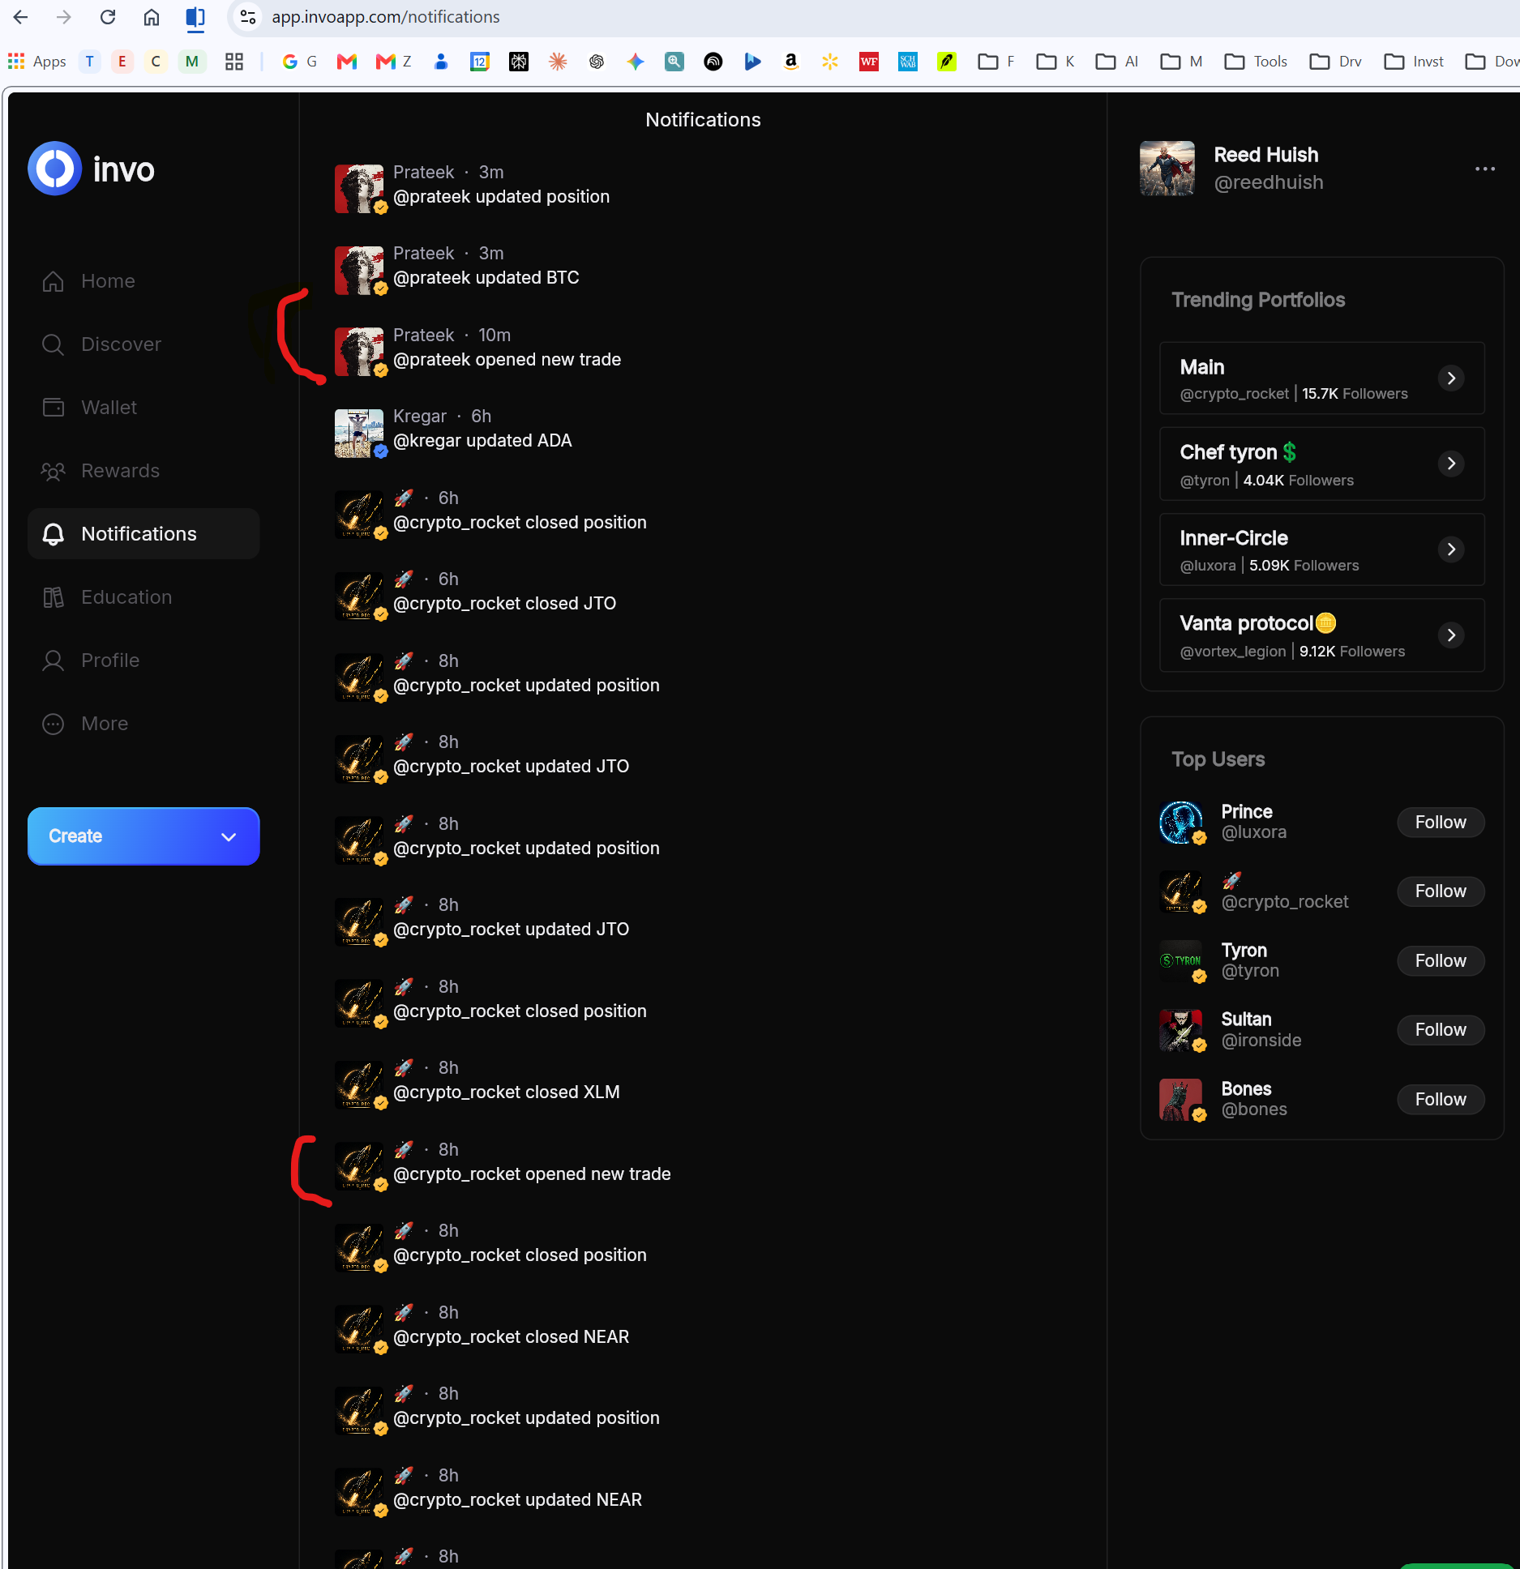

I marked the ones in RED that tampermonkey got the signal and clicked MIMIC (usually within 20-30 seconds of the “opened new trade” being posted)

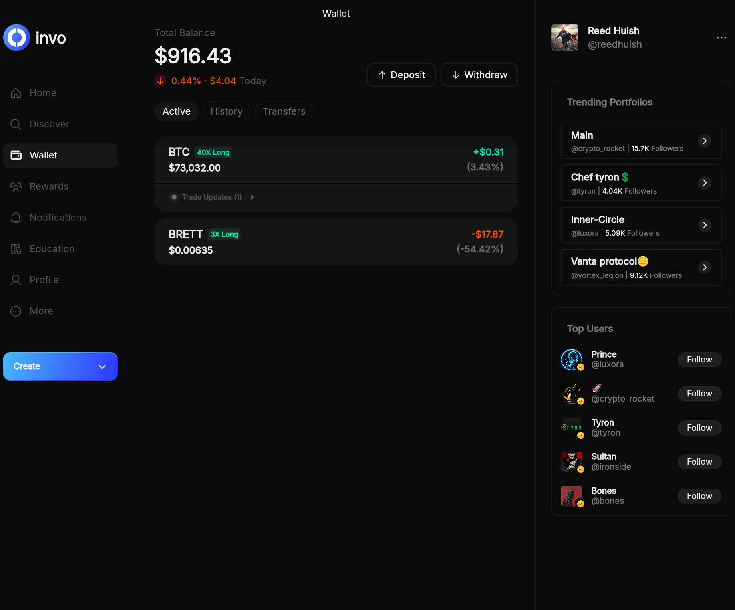
On the wallet page it does ALL the trade updates, including doing a default mimic of all the trader updates to that trade. And when the trader closes the Trade it closes it too. Usually within about 30-45 seconds.

5- You need to CHOSE YOUR TRADE PROFILES -- add them to your watch list in your Involio account. This will automate the Mimic. It should do everything for you. If you select a Trade Profile you don't want. DO NOT ADD IT to your Invo account (i.e., do not WATCH that trade profile). Good or bad, it will automate it.

I set a stop loss coded at 2%. I'm playing with this right now. Again I used Claude to update the Python script, add this to Claude (I use the free version) and it will understand exactly what is being done. And you can tweak and automate this as you see fit.

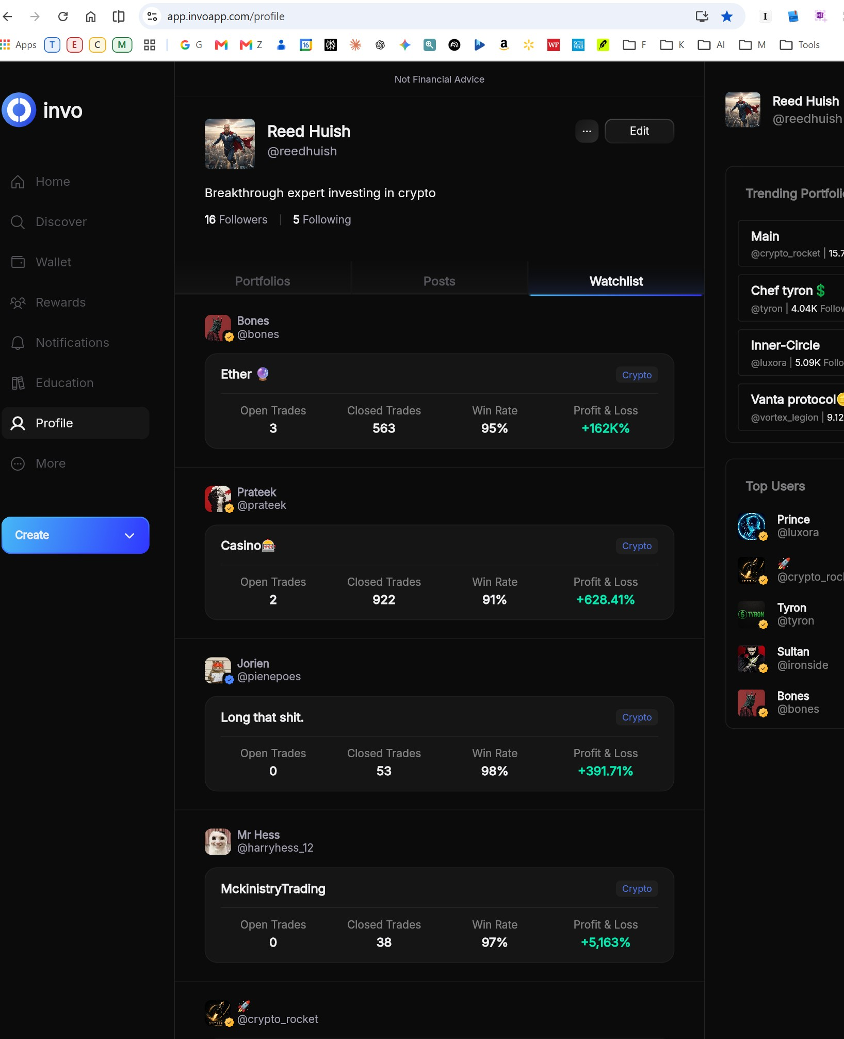

6- I run this 24-7 on my "trading windows PC". Even when the screen turns off, it is still running those 2 browsers. I don't put my windows PC to sleep. Please make sure the Chrome browser doesn't go to sleep or minimize. It always has to be active. Sorry, but this is the only way I've found to do this (until the API comes!)

Setup Windows PC running so it doesn't sleep
Go to Settings → System → Power & Sleep:
- Screen: "Turn off after" → your 2 hours is fine ✅
- Sleep: Never (plugged in)
Go to Settings → Windows Update → Advanced Options → Active Hours:
- Set to 6am–3am — prevents forced restarts overnight
Go to Task Manager → Startup Apps — disable anything that could cause overnight reboots.

Chrome Browser sleeping
1. Disable Memory Saver (Built-in)
Chrome has an automatic feature that puts inactive tabs to sleep to save memory. You can completely disable this or whitelist your important tabs. [1, 2]
Method 1: Prevent Chrome from putting the site to sleep
Chrome has a built-in Memory Saver that automatically deactivates tabs. To stop it from affecting app.invoapp.com: [1, 2]
- Open Google Chrome.
- Click the three dots in the top-right corner and select Settings.
- Click on Performance in the left-hand menu.
- Locate the Always keep these sites active setting.
- Click the Add button, type in app.invoapp.com, and click Add. [1, 2]

7. Here are the complete settings changes you can modify in the Javascript

(I just use NOTEPAD to edit it, just like its a text or txt file)

All settings are at the very top of the script — change one value, save, reload tabs.
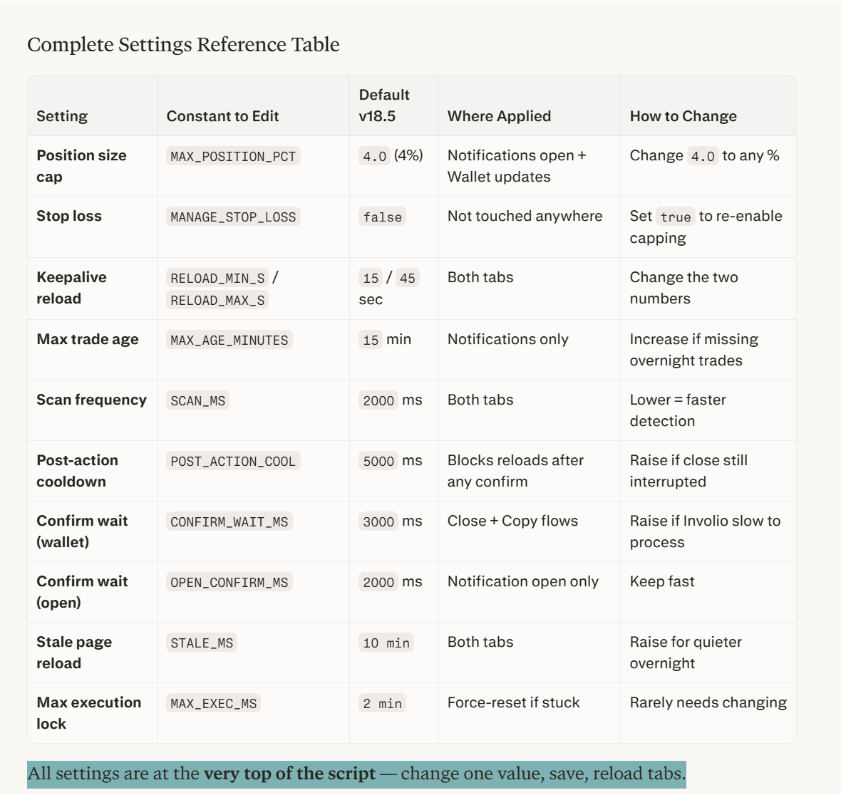

here are items adjustable in the Javascript code:

Setting | Constant to Edit | Default v18.5 | Where Applied | How to Change
Position size cap | MAX_POSITION_PCT | 4.0 (4%) | Notifications open + Wallet updates | Change 4.0 to any %
Stop loss | MANAGE_STOP_LOSS | false | Not touched anywhere | Set true to re-enable capping
Keepalive reload | RELOAD_MIN_S / RELOAD_MAX_S | 15 / 45 sec | Both tabs | Change the two numbers
Max trade age | MAX_AGE_MINUTES | 15 min | Notifications only | Increase if missing overnight trades
Scan frequency | SCAN_MS | 2000 ms | Both tabs | Lower = faster detection
Post-action cooldown | POST_ACTION_COOL | 5000 ms | Blocks reloads after any confirm | Raise if close still interrupted
Confirm wait (wallet) | CONFIRM_WAIT_MS | 3000 ms | Close + Copy flows | Raise if Involio slow to process
Confirm wait (open) | OPEN_CONFIRM_MS | 2000 ms | Notification open only | Keep fast
Stale page reload | STALE_MS | 10 min | Both tabs | Raise for quieter overnight
Max execution lock | MAX_EXEC_MS | 2 min | Force-reset if stuck | Rarely needs changing

All settings are at the very top of the script — change one value, save, reload tabs.

